Reginald True

Professor lles

CS 360

March 23 2025

3-2 Assignment

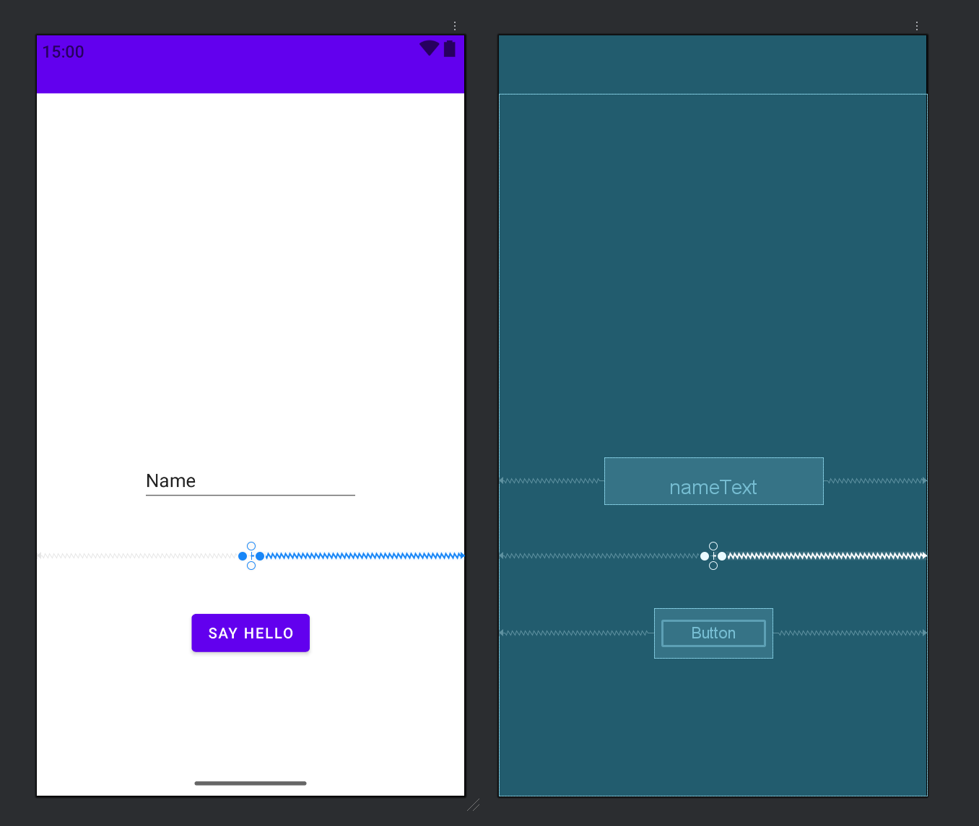

Trying out Android Studio for the first time during this course was exciting, but also a little tricky. There are a lot of buttons and tools, and it took me some time to figure out where everything is and how it works. One hard part was adding buttons to the screen. I tried to drag a button onto the layout, but it wouldn’t stay. Later, I learned that in something called ConstraintLayout, you have to connect the button to the sides of the screen, or it won’t show up right. That part was a little confusing at first. Another problem I had was using the emulator, which is like a pretend phone on the computer. It was really slow, and sometimes it would freeze or not work at all. I’m going to try using a real phone instead to test my apps.

I’m still learning how the code and the layout files work together. Should I keep using the easy layout called LinearLayout, or should I start learning the harder one, ConstraintLayout, right away? The more I use it the more comfortable I have gotten and can’t wait to master it during this course